1972
What type of isomerism are possible among the molecules that can be obtained by substituting a chlorine atom and a bromine atom for two of the hydrogen atoms in each of the following?
(a) Ethane, C₂H₆
(b) Ethene, C₂H₄
Show structures to illustrate each of the types of isomerism you name for each of these compounds.
Answer:
(a) positional (structural) isomers
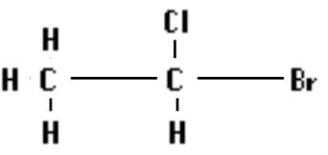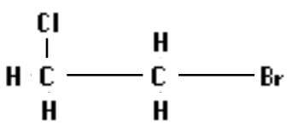
optical isomer:
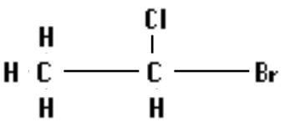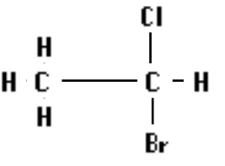
(b) positional (structural) isormers
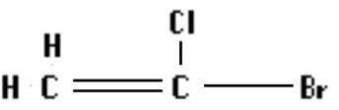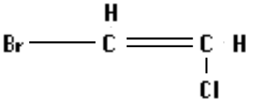
cis - trans isomers
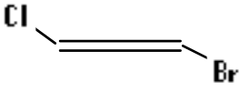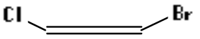

1974 D
Briefly discuss the following statement:
“The functional group concept is important in organizing the information of organic chemistry.”
Support your discussion by giving two chemical equations to illustrate the application of this concept for each of two functional groups.
Answer:
Rationale on scoring:
Discussion of functionality (structural feature reacting as a unit; reactivity relatively independent of the rest of molecule) - 2 points
Correct identification of functional groups - 2 points
Equations illustrating reactivity - 3 points

1975 D
Draw structural formulas for seven different isomers of C₃H₄Cl₂.
Answer:
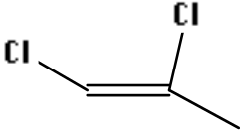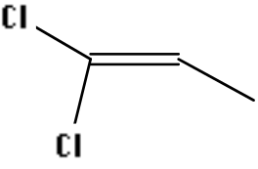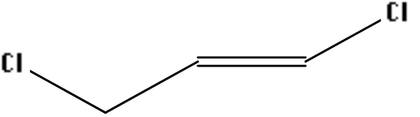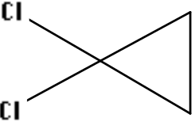
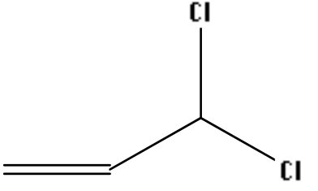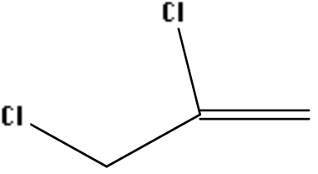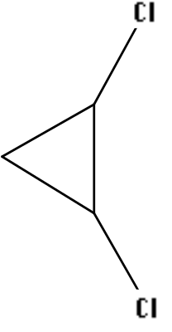

1977 D
Write structural formulas for two stable isomers X and Y that have the molecular formula C₂H₄O₂. Select a physical property and a chemical property that would distinguish between the two isomers in the laboratory. Explain.
Answer:
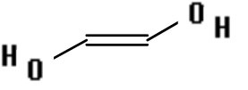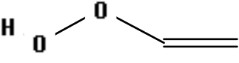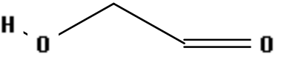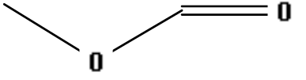

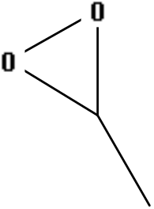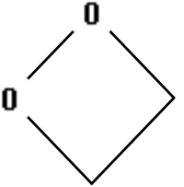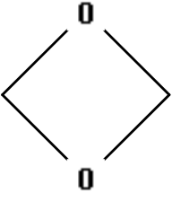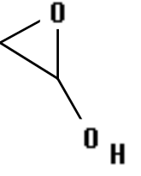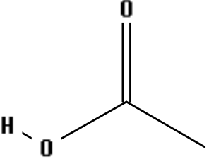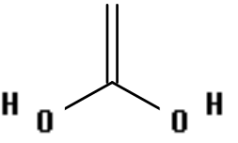
Correct distinguishing physical property: solubility, odor, boiling point, pH of aqueous solution, etc.
Correct distinguishing chemical property: type of reaction, acid or reducing property, conductivity, or pH of solution, etc.

1978 D
Dehydration of 3-hexanol yields a mixture of four isomers each with the molecular formula C₆H₁₂. Draw structures of the four isomers and name each of them.
Answer:
trans-3-hexene cis-3-hexene
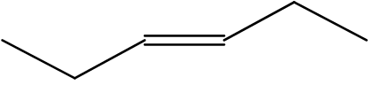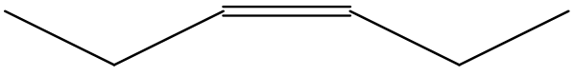
trans-2-hexene cis-2-hexene
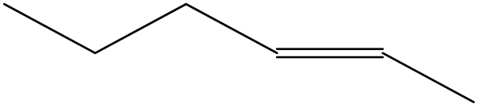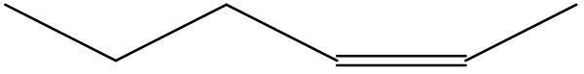

1981 D
Assume that you have two different gases that you know are not cyclic (i.e. not ring) compounds, each with the following elementary analysis: C = 85.7%, H = 14.3%. Each gas has a molecular weight of 56¦1.
(a) What is the molecular formula for the compounds?
(b) Draw the structural formulas for the four possible noncyclic isomers with this molecular formula.
(c) In the presence of an appropriate catalyst, both gases add hydrogen. The hydrogenated products are identical, their molecular weight is 58. Which of the structures you drew to answer (b) can definitely be eliminated on the basis of this additional information?
Answer:
(a) 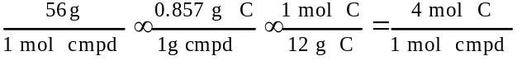 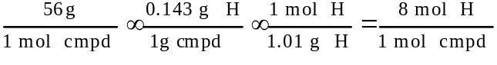
molecular formula: C₄H₈
(b)
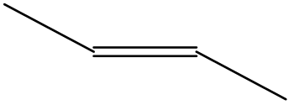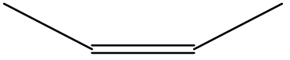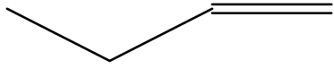
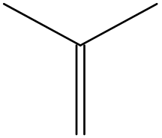
(c) The last formula in Part (b) can be eliminated (2-methyl-1-propene).

1998 D
Answer each of the following using appropriate chemical principles.
(c) Dimethyl ether, H₃C-O-CH₃, is not very soluble in water. Draw a structural isomer of dimethyl ether that is much more soluble in water and explain the basis of its increased water solubility.
In each case, justify your choice.
Answer
(c) 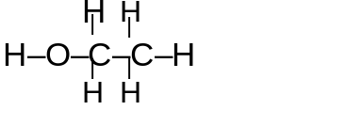The O-H bond in ethyl alcohol is very polar and will allow the molecule to be attracted to and dissolve in the polar water.

